**Lesson 3 Demo 13**

**Managing Kubernetes Objects**



Steps to be followed:

1. Getting a list of persistent volumes

**Step 1: Getting a list of persistent volumes**

1. Type the following command to get a list of persistent volumes:

***kubectl get pv***



1. Write the output of the previous step to a yaml format by adding:

***kubectl get pv -o yaml***

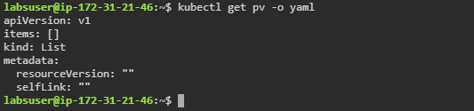

1. Sort PersistentVolumes by storage capacity and store it in a text file

***kubectl get pv --sort-by = .spec.capacity.storage > some.txt***

